**COMFTAALGOTO5: Algo-trading, Theory and Practice**

**Group Assignment**

MOMENTUM STRATEGY IN BALANCE PORTFOLIO

Benson Lai

Ramesh Musuvathi

Evelyn Kang



**Table of Contents**

Strategy Introduction 2

Portfolio Performance – Period Jan 2011- Jan 2021 2

Methods 3

Python scripts 4

Challenges 6

Opportunities 6

Strategy Performance Report 7

Cumulative Returns 7

Drawdown 7

Sources and Works Cited 8

# Strategy Introduction

The aim of this exercise to present a strategy to achieve moderate returns using a balanced portfolio of assets. For this purpose, we have allocated capital in the following asset classes identified at the specified percentages

1. 40% of capital - Top performing REIT Stocks from the S & P (“SPY”) index
2. 45% of capital - Vanguard FTSE Developed Markets ETF (“VEA”)
3. 15% of capital - SPDR Gold Trust (“GLD”)

The reasons for selecting REIT, ETFs and Gold are for diversification and for their inherent qualities of having a consistent rising momentum throughout the decade and stable growth over longer period of time. In addition, the REIT asset class distributes their profits as dividends which could be an uplift to the capital invested. In short, we believe that the above allocation optimizes the returns for the investors over a longer time period. The CAGR is expected to be ~4% over 10 year period. The important point to note is, the portfolio has performed through the Global, financial crisis, US debt crisis, European debt crisis, Fukushima meltdown and the latest COV-ID pandemic.

# Portfolio Performance – Period Jan 2011- Jan 2021

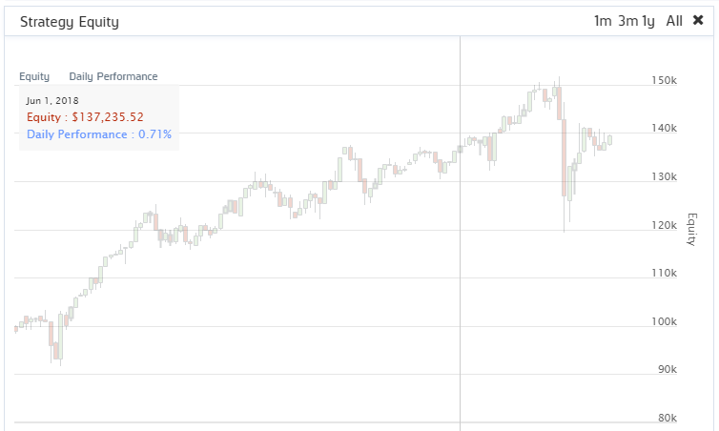

# Methods

As indicated, the assets in the portfolio were identified to provide stable returns. To fine tune the returns, the momentum strategy is adopted. This momentum strategy assumes that the asset which grows strongly in the past will continue to grow in the near future too. This strategy captures the rate of change over a period of 11 months and reallocates the portfolio to provide stable returns on quarterly basis. The following trading confirmations are made in the algorithm to safeguard investor’s interest

1. Quarterly Portfolio reallocation will not happen if the total portfolio value is less than the invested value (e.g. US$ 100,000 in our case).
2. Algorithm cross checks the month and allocates only every quarter.
3. The component companies of the REIT asset portfolio will be liquidated and reallocated every quarter. The Algorithm selects top 5-10 companies in the S & P REIT portfolio and allocates the capital in them accordingly. If the REIT stock is not in top 5 selection criteria, that particular REIT stock will be dropped for that quarter during asset re allocation.

The algorithm selects the REIT stocks on the basis of coarse and fine universe selection. In this an investment universe of coarse stocks pack that have prices greater than US$, contains fundamental data and have a trading volume more than 1,000,000 is created and then from this coarse stocks pack, the algorithm filters out the REIT only stocks using the Morningstar field “IsREIT” property.

From the fine-tuned stock pack, the algorithm calculates each REIT’s 11 month return one month lagged and rank them in the ascending order. Once ranked bottom to top, the algorithm picks up the top 5-10 performing stocks from the fine-tuned list and invests accordingly.

# Python scripts

class VentralVerticalCircuit(QCAlgorithm):

def Initialize(self):

self.SetStartDate(2011,1,1) #Set Start date

self.SetEndDate(2021,1,1) #Set end date

self.SetCash(100000) # Set Strategy Cash

#selecting top performing REIT's using coarse and fine selection logic

self.UniverseSettings.Resolution = Resolution.Daily

self.filtered_fine = None

self.AddUniverse(self.CoarseSelectionFunction,self.FineSelectionFunction)

self.AddEquity("SPY", Resolution.Daily)

self.AddEquity("VEA", Resolution.Daily) # Vanguard FTSE Developed Markets ETF

self.AddEquity("GLD", Resolution.Daily) # SPDR Gold Trust

#self.AddEquity("TLT", Resolution.Daily) # iShares 20+ Year Treasury Bond ETF

# self.AddCrypto("BTCUSD", Resolution.Daily) # Bitcoin

#self.AddEquity("GLD", Resolution.Daily) # SPDR Gold Trust

#monthly scheduled event

self.Schedule.On(self.DateRules.MonthStart("SPY"), self.TimeRules.At(23, 0), self.rebalance)

self.months = -1

self.quarterly_rebalance = False

self.acc_returns = 0

def CoarseSelectionFunction(self, coarse):

if self.quarterly_rebalance:

# drops penny stocks, stocks that have more than 10000 Volume and stocks with no fundamental data

self.filtered_coarse = [x.Symbol for x in coarse if (float(x.Price) > 1)

and (x.HasFundamentalData)

and float(x.Volume) > 1000000]

return self.filtered_coarse

else:

return []

def FineSelectionFunction(self, fine):

if self.quarterly_rebalance:

#filters out the companies that are not REITs

fine = [x for x in fine if (x.CompanyReference.IsREIT == 1)]

#calculating the momentum using 6 month (1-day lagged) returns

start = self.Time-timedelta(days = 360)

end = self.Time-timedelta(days = 30)

for x in fine:

hist = self.History([x.Symbol],start,end,Resolution.Daily)

if not hist.empty:

start_price = hist["close"].iloc[0]

end_price = hist["close"].iloc[-1]

x.momentum = (end_price-start_price)/start_price

fine = [x for x in fine if hasattr(x, 'momentum')] #hasattr returns true if certain attributes are present

#we sort REITs based on their returns

sorted_filter = sorted(fine, key=lambda x: x.momentum)

self.filtered_fine = [i.Symbol for i in sorted_filter]

return self.filtered_fine

else:

return []

def rebalance(self):

#halfyearly rebalance

self.months+=1

if self.months%3 == 0:

self.quarterly_rebalance = True

self.Debug("in Rebalance month" + str(self.months))

def OnData(self, data):

pvalue = self.Portfolio.TotalPortfolioValue

self.Debug("Portfolio size is US$" + str(pvalue))

if not self.quarterly_rebalance: return

self.SetHoldings("VEA", 0.45) #allocate 45% to ETF

# self.SetHoldings("TLT", 0.15) #allocate 25% to bond

self.SetHoldings("GLD", 0.15) #allocate 15% to gold

# self.SetHoldings("BTCUSD", 0.05) #allocate 5% to crypto

if self.Portfolio.TotalPortfolioValue < 100000:

self.Debug("Portfolio size is less than 100000...Status quo" + str(pvalue))

return

if self.filtered_fine: # allocating 40% to REIT stocks which has good momenetum in the previous six months

self.Debug( "in the ondata module" + str(self.months))

portfolio_size = int(len(self.filtered_fine)/6)

self.Debug("Portfoliosize " + str(portfolio_size))

#selecting top 10-15 stocks in the portfolioc, sorted list is in ascending order,that is the reason we used -portfolio size:

long_stocks = self.filtered_fine[-portfolio_size:]

stocks_invested = [x.Key for x in self.Portfolio]

for i in stocks_invested:

#liquidate the stocks not in our filtered_fine list

if i not in long_stocks:

self.Liquidate(i)

self.Debug("Liquidating+"+ str(i))

elif i in long_stocks:

self.SetHoldings(i, (0.4/(portfolio_size)))

self.Debug("reallocating portfolio")

self.quarterly_rebalance = False

self.filtered_fine = None

# Challenges

The challenges in staying profitable for this algorithms are

1. Investors should stay invested for long term. This could be a challenge for traders. The maximum drawdown is ~20%. So traders shouldn’t liquidate during bad market fluctuation.
2. Since the portfolio is rebalance using 11 month period momentum, there is a good chance that algorithm could miss some good investment opportunities with the 11 month period. The solution to this could be shortening the 11 month period to 6 months.
3. Macroeconomic indicators like interest rates will require adjustment to the asset reallocation within the portfolio.
4. Property market are affected and algorithm needs to adjust to the new normal.

# Opportunities

The opportunities in staying profitable for this algorithms are

1. Opportunities to capture cheap valued assets during bad times.
2. Industrial REITS can be considered instead of diversified REIT to increase returns.
3. Macroeconomic indicators like interest rates will require adjustment to the asset reallocation within the portfolio for increasing the CAGR.

# Strategy Performance Report

**Monthly Returns**

|  |  |  |  |  |
| --- | --- | --- | --- | --- |
| **Key Statistics** |  |  |  |  |
| Day s Live |  | CAGR | 3.4 % |  |
| Turnover | **1** % | Drawdown | 21.4 % |  |
| Kelly Estimate | 0.0 | Sharpe Ratio | 0.4 |  |
| Probabilistic SR | **2%** | Information Ratio | -0.5 |  |
| Markets | Equity | Trades Per Day | 0.2 |  |

# Cumulative Returns

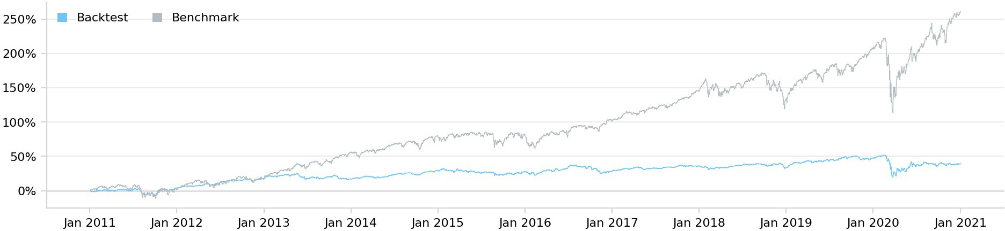

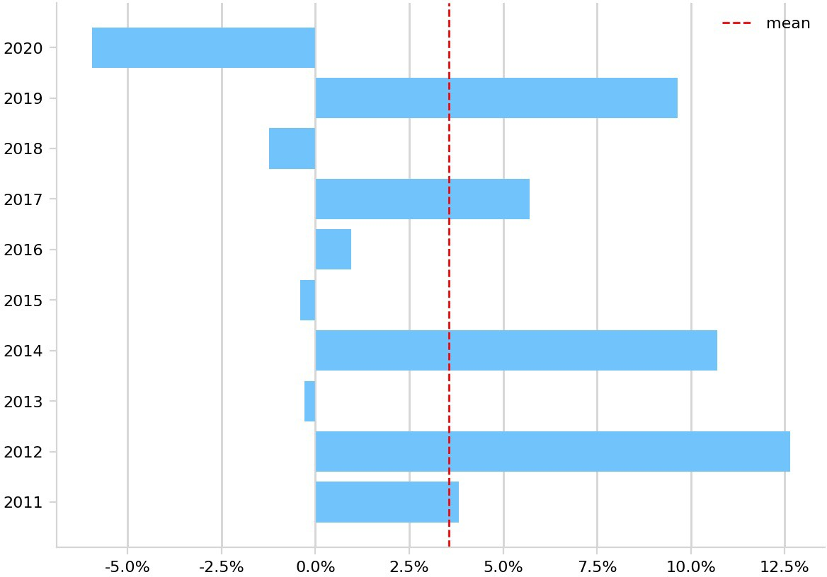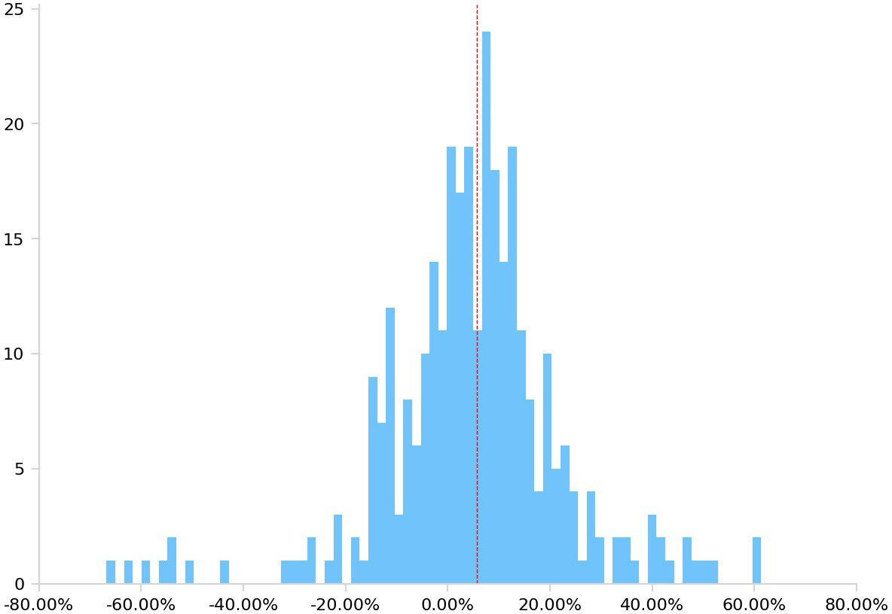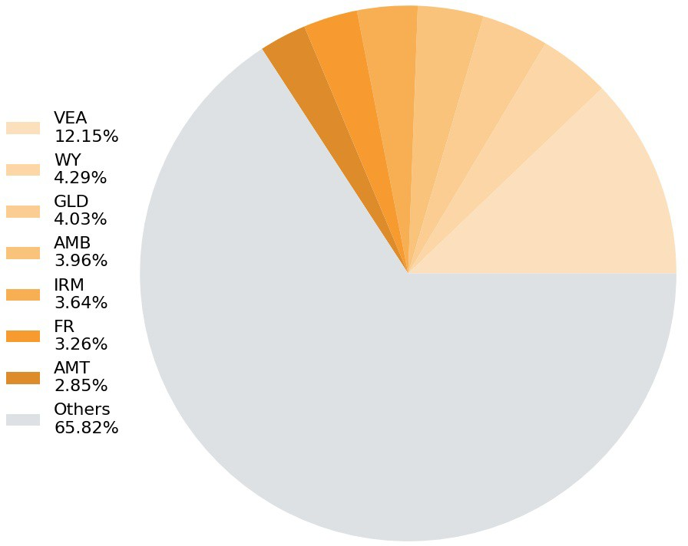**Annual Returns Returns Per Trade Asset Allocation**

# Drawdown

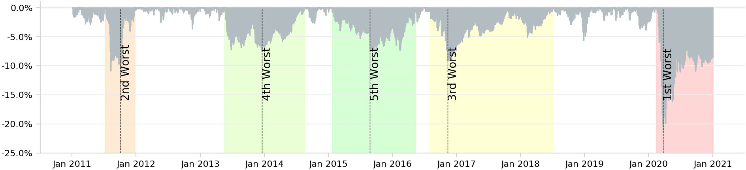

**QUANT CONNECT @** Strategy Report Summary : group7project

Global Financial Crisis Jan 2011 - Dec 2011

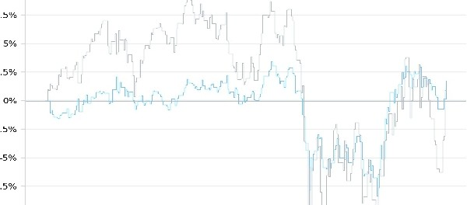

ECB IR Event 2012 Sep 2012 - Oct 2012

_f ',

Fukushima Meltdown Mar 2011 - Apr 2011

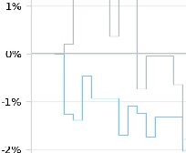+

European Debt Crisis Oct. 2014 Oct 2014 - Oct 2014

,-l

U.S. Downgrade/ European Debt Crisis Aug 2011 - Sep 2011

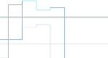

Market Sell-Off 2015 Aug 2015 - Oct 2015

LL 





Recovery Jan 2011 - Oct 2012 New Normal Jan 2014 - Jan 2019 COVID-19 Pandemic Feb 2020 - Sep

2020

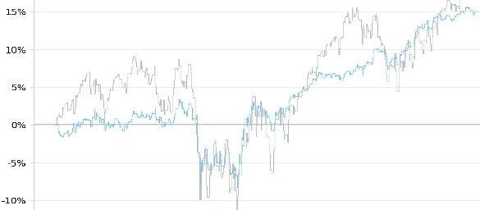'1· fl

*,l*

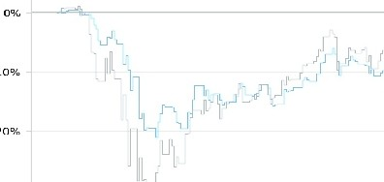*(* i' I

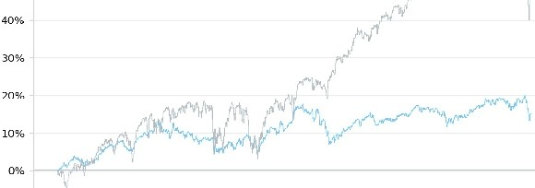/'

# Sources and Works Cited

Strategy Library, Momentum Effect in REITs from [www.quantconnect.com](http://www.quantconnect.com)